Notes on sablefish ageing
Ian Stewart
5/10/2010

Patrick’s reads tend to be 1-3 years below other sources (tagging, AFSC, ADFG, DFO). However, the slight bias is quite consistent across ages and well within the expected spread of ages given that all methods are imprecise.
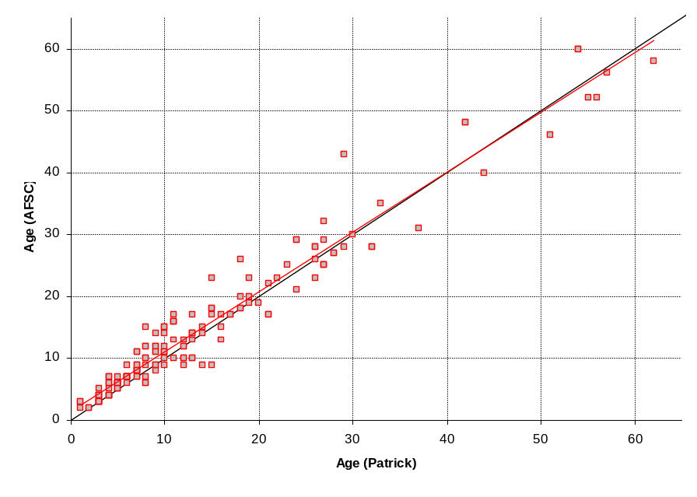
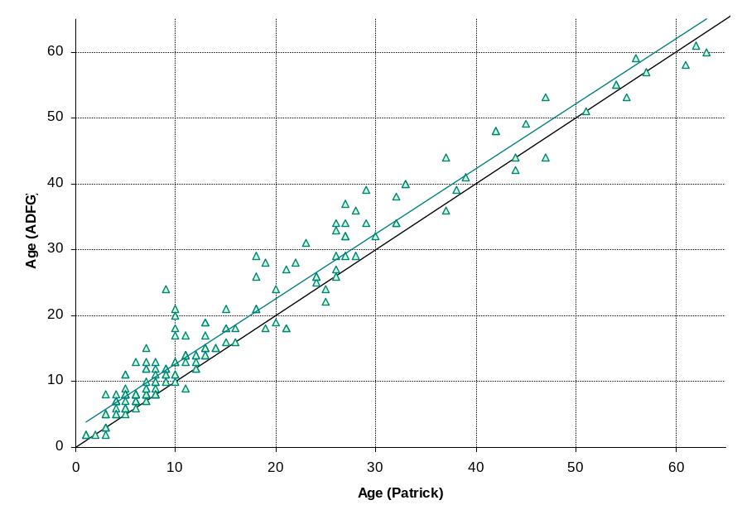

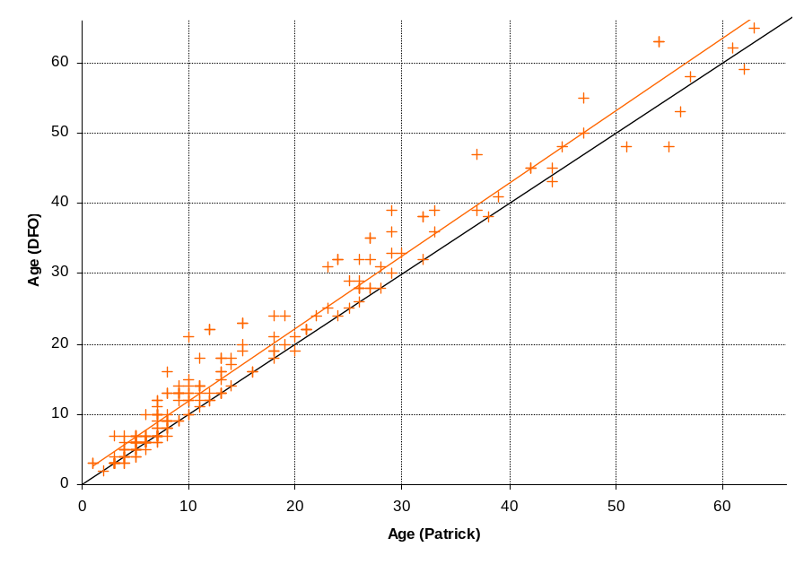
The spread appears wider for the tagging-based ages, but only because none of the fish are very old.
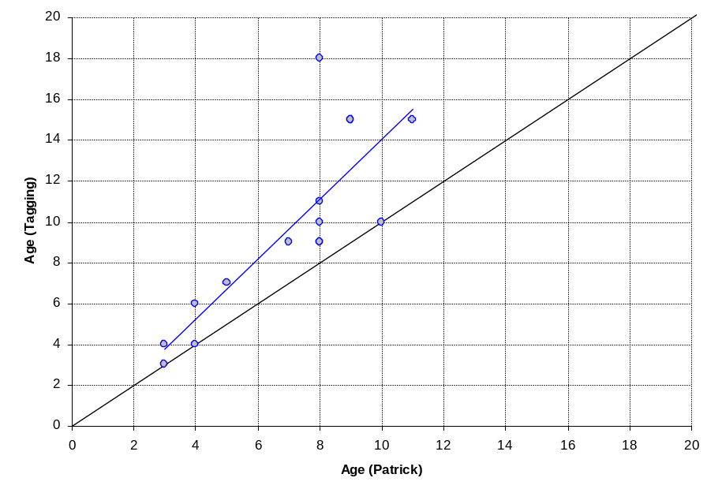

When AFSC is compared to the tagged fish, they are quite close (did they train their readers with these fish?).
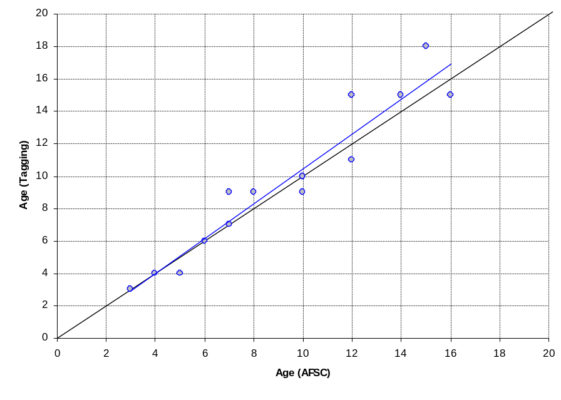

AFSC and other age labs are very concerned with getting the ‘right’ age. We don’t require that, just that the ages we receive are consistently produced. As long as we have comparison reads on the same bones from all sources (5 reads on a single bone is the most powerful approach, but multiple comparisons among sources (e.g., AFSC x CAP for 100 otoliths, ADFG x DFO for 100 otoliths, etc.) are fine too as long as all methods are linked through at least one comparison. Ultimately we have to assign one method to be either unbiased, or to have a known degree of bias (perhaps from radiocarbon or stable isotopes). We can then estimate the degree of bias for other methods directly from the cross-lab reads and the degree of precision from the cross-lab reads and within-lab double reads (it helps to have lots of these). The bias and precision are then used directly in the stock assessment such that each source of age information carries the appropriate reading characteristics. Unfortunately, in this case the 2007 sablefish assessment assumed there was NO bias in any of the age reads, and that all reads were PERFECTLY precise.

Questions:
- Do we have any reason to think that the tagged sablefish may be easier or harder to read than fish from the west coast? This is important if we are to use them as a reference set.
- Presumably the AFSC ages are ‘reconciled’ as they usually do, with something like 20% of the ages read by more than one reader and some ‘agreed’ age treated as the best estimate. We usually assume ages produced using this approach will be slightly more precise (but not necessarily less biased) than single-reads. Can we verify whether these ages represent single or multiple reads?
- Have we done any work looking at the marginal increment to understand when the band is laid down during the calendar year and also when the bulk of the growth is taking place (presumably summer)? I don’t consider this to be validation, but it can explain 1 ‘year’ of difference between agers if the margin is or isn’t counted. We may need to pay more attention to this in general.

Preliminary recommendations:
- Continue ageing sablefish as consistently with previous efforts as possible.
- Let’s inventory the double-reads we currently have (including any for AFSC, ADFG, and DFO).
- With the full data set of double reads and the CARE exchange data set I can estimate the bias and imprecision for all methods assuming the tagging-based estimates are unbiased.
- Otolith weight from the tagging-based age estimates can be explored and may provide a corroboration of the degree of bias we see. If so, it may be possible to build a much larger data set of ‘unbiased’ estimates to better inform the relationships; however we will be missing validation of the method for medium to older age fish which will remain quite problematic.
- The 2011 assessment will ultimately have to explicitly accommodate our improved understanding of sablefish ageing – both bias and imprecision.

